**Nomination Form**

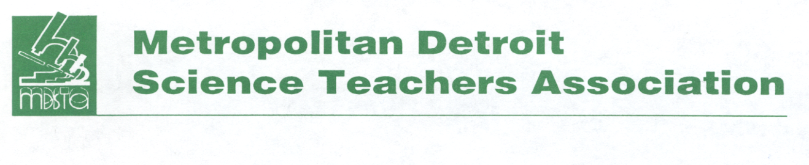

**Outstanding Science Educator Award Application**

The Metropolitan Detroit Science Teachers Association continues to promote and recognize excellence in teaching. Please help us to identify those friends and colleagues whose work is outstanding by completing the nomination form.

**Selection Criteria (Information for Bio)**

* Nominees must be current members of MDSTA at the time of nomination.
* Nominees must have made significant contributions in the classroom and in other professional activities.

These should include one or more of the following:

* **Idea sharing with colleagues**
* **Presentations at professional workshops or conferences**
* **Written or developed curriculum materials**
* **Participation in extracurricular science activities**

Name of Nominee: _____________________________________________________________________

Home Address: ________________________________________________________________________

City, State, Zip: ________________________________________________________________________

Email address: _________________________________________________________________________

Home or cell phone: ____________________________________________________________________

Name of School and District: _____________________________________________________________

**Award Category (Circle One)** **Elementary** **Middle School**  **High School**

Date: ________________________________________________

Your Name:___________________________________________________________________________

Your Phone: ________________________________ Email: _____________________________________

Please submit **three** **letters of support and a one page biography** of the nominee’s professional contributions along with this form. Questions? Contact Debby Peters at 248.642.6326 or [djapeters@gmail.com](mailto:djapeters@gmail.com).

Nominations are accepted from November through April for award consideration for the current school year. **All materials must be postmarked by April 1st and mailed to:**

**MDSTA, Attention OSEA**

**P.O. Box 111**

**Southfield, MI 48037 or**

**email to:** [**mdsta1941@gmail.com**](mailto:mdsta1941@gmail.com)